- TIC TAC TOE
import random
board = [" "] * 9
wins = [(0,1,2),(3,4,5),(6,7,8),
(0,3,6),(1,4,7),(2,5,8),
(0,4,8),(2,4,6)]
while True:
print(board[:3])
print(board[3:6])
print(board[6:])
n = int(input("Enter index (1-9): ")) - 1
if n < 0 or n > 8 or board[n] != " ":
print("Invalid or occupied!")
continue
board[n] = "X"
if any(all(board[i] == "X" for i in w) for w in wins):
print("You win!")
break
if " " not in board:
print("Draw!")
break
empty = [i for i in range(9) if board[i] == " "]
num = random.choice(empty)
board[num] = "O"
if any(all(board[i] == "O" for i in w) for w in wins):
print(board[:3], board[3:6], board[6:], sep="\n")
print("Computer wins!")
break
OUTPUT 1:
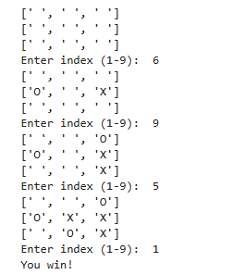
OUTPUT 2:
